SQL PROJECT

**Library Management System**

* Here we are building a project based on Library Management System. It keeps track of all information about books in the library, their cost, status and total number of books available in the library.
* So first we can create a database named ‘library’

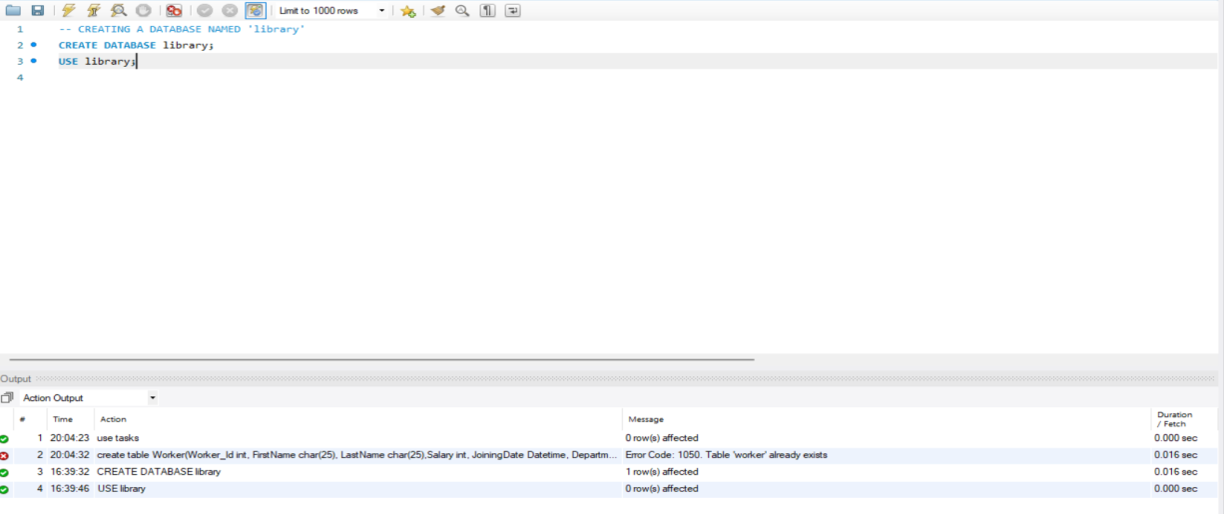

* Now we can create Tables in this database. The tables name and its attributes are given below

1. Branch   
2. Employee   
3. Books  
4. Customer  
5. IssueStatus  
6. ReturnStatus   
  
Attributes for the tables:   
  
1. Branch

* Branch_no - Set as PRIMARY KEY
* Manager_Id
* Branch_address
* Contact_no

2. Employee

* Emp_Id – Set as PRIMARY KEY
* Emp_name
* Position
* Salary
* Branch_no - Set as FOREIGN KEY and it refer Branch_no in Branch table

3. Books

* ISBN - Set as PRIMARY KEY
* Book_title
* Category
* Rental_Price
* Status [Give yes if book available and no if book not available]
* Author
* Publisher

4. Customer

* Customer_Id - Set as PRIMARY KEY
* Customer_name
* Customer_address
* Reg_date

5. IssueStatus

* Issue_Id - Set as PRIMARY KEY
* Issued_cust – Set as FOREIGN KEY and it refer customer_id in CUSTOMER table  Issued_book_name
* Issue_date
* Isbn_book – Set as FOREIGN KEY and it should refer isbn in BOOKS table

6. ReturnStatus

* Return_Id - Set as PRIMARY KEY
* Return_cust
* Return_book_name
* Return_date
* Isbn_book2 - Set as FOREIGN KEY and it should refer isbn in BOOKS table

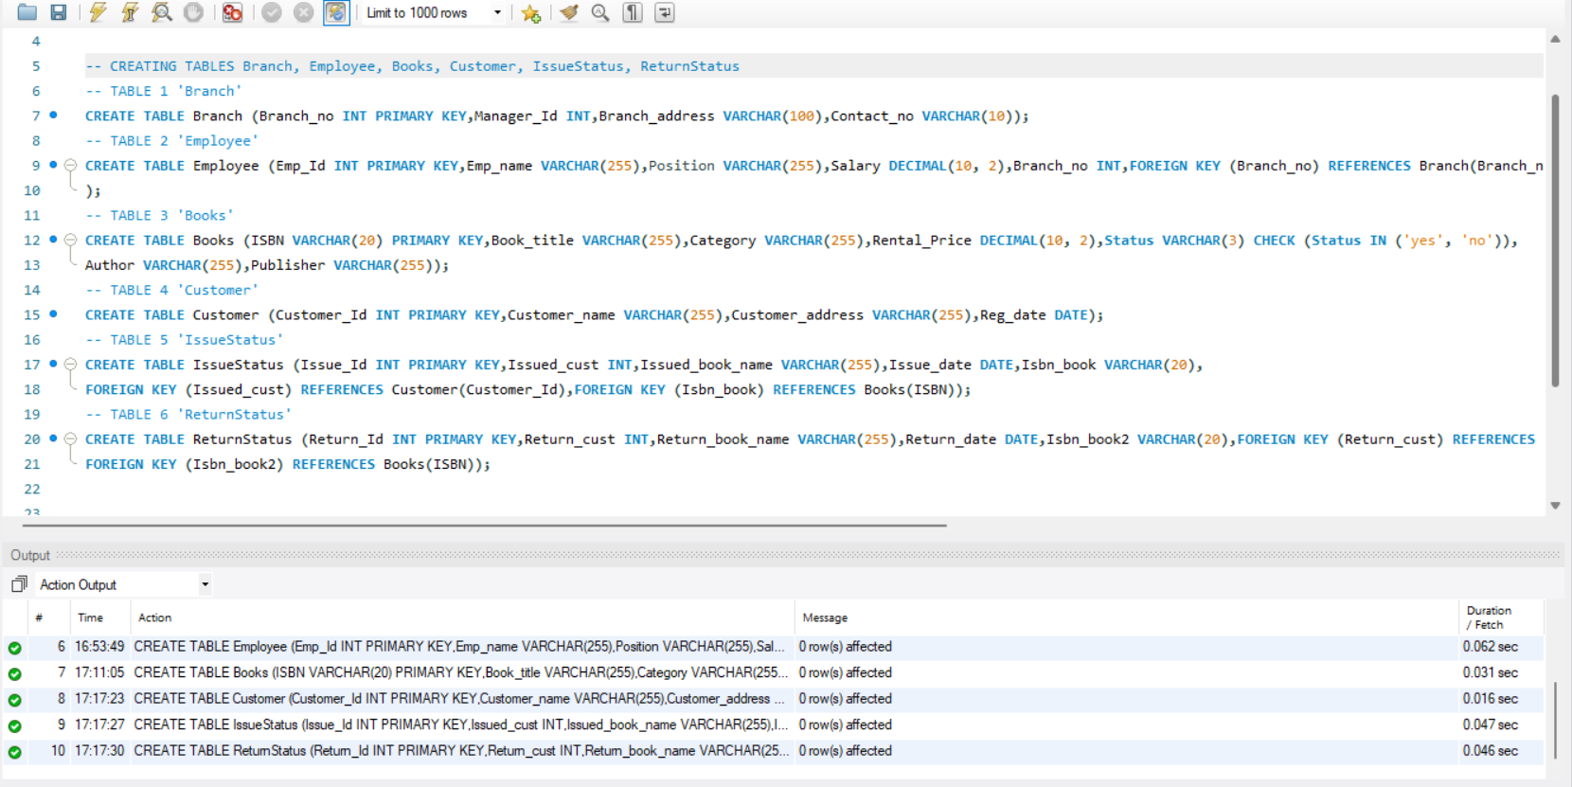

* Now insert the values into the each table for proper functioning

1. First for the table Branch

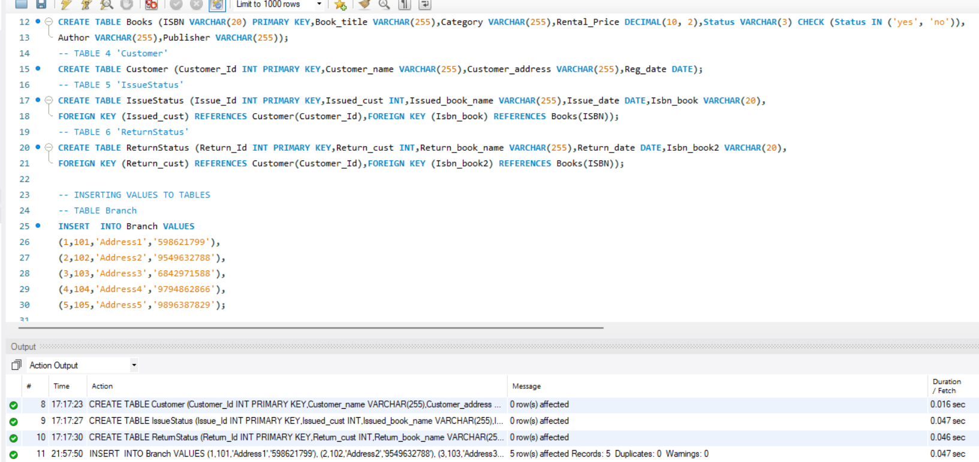

1. Records for the table Employee

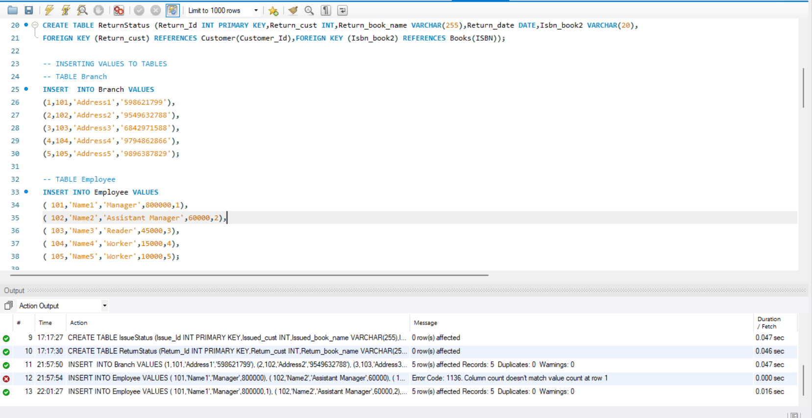

1. Records of the table Books and Customer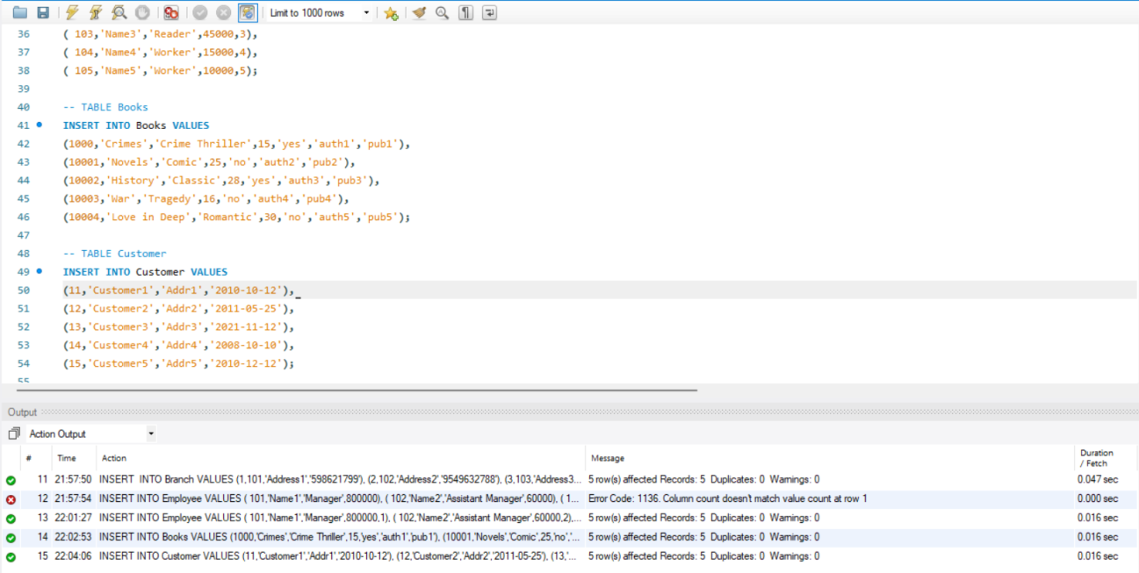
2. Records of the table IssueStatus

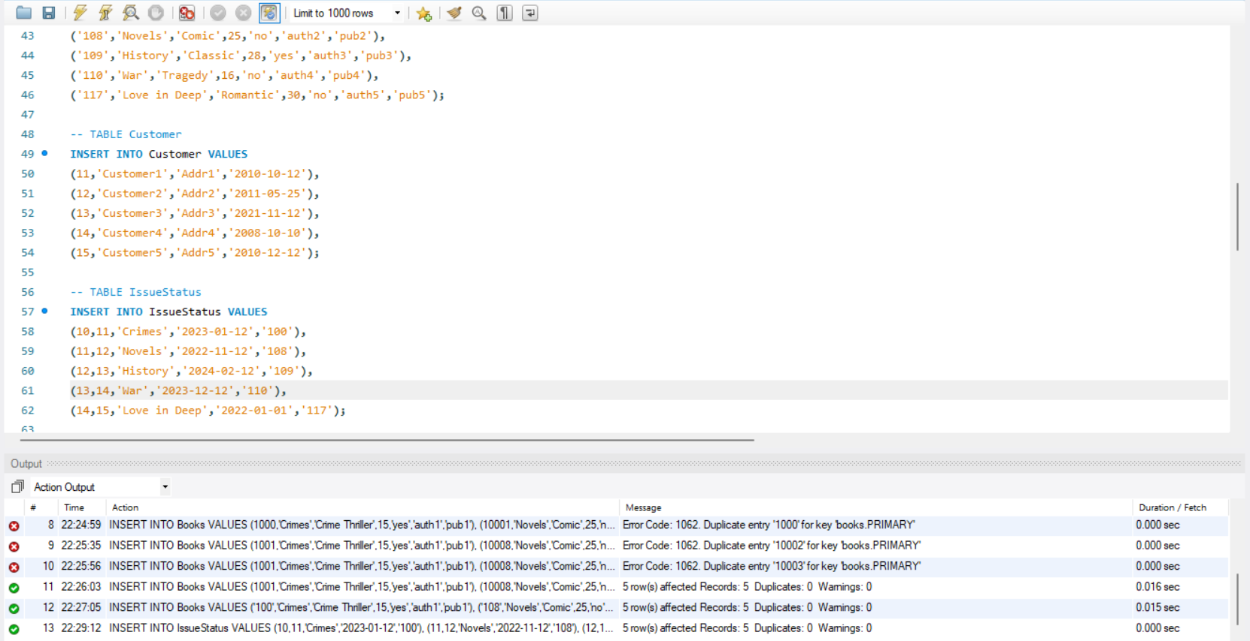

1. For the table ReturnStatus

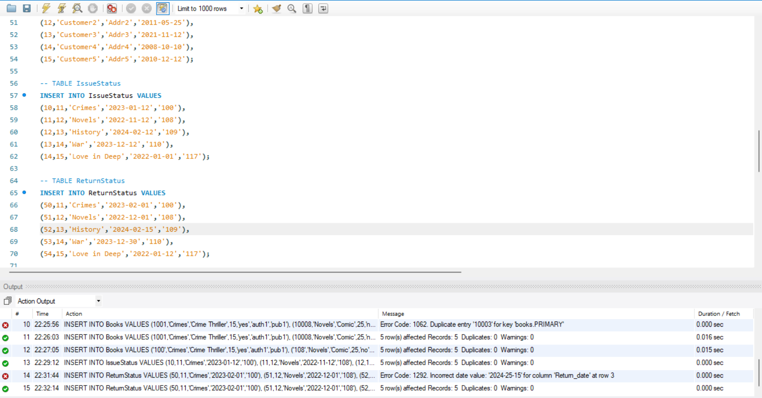

* Retrieve the book title, category, and rental price of all available books.

Here we can see the details of books where the book status is ‘yes’

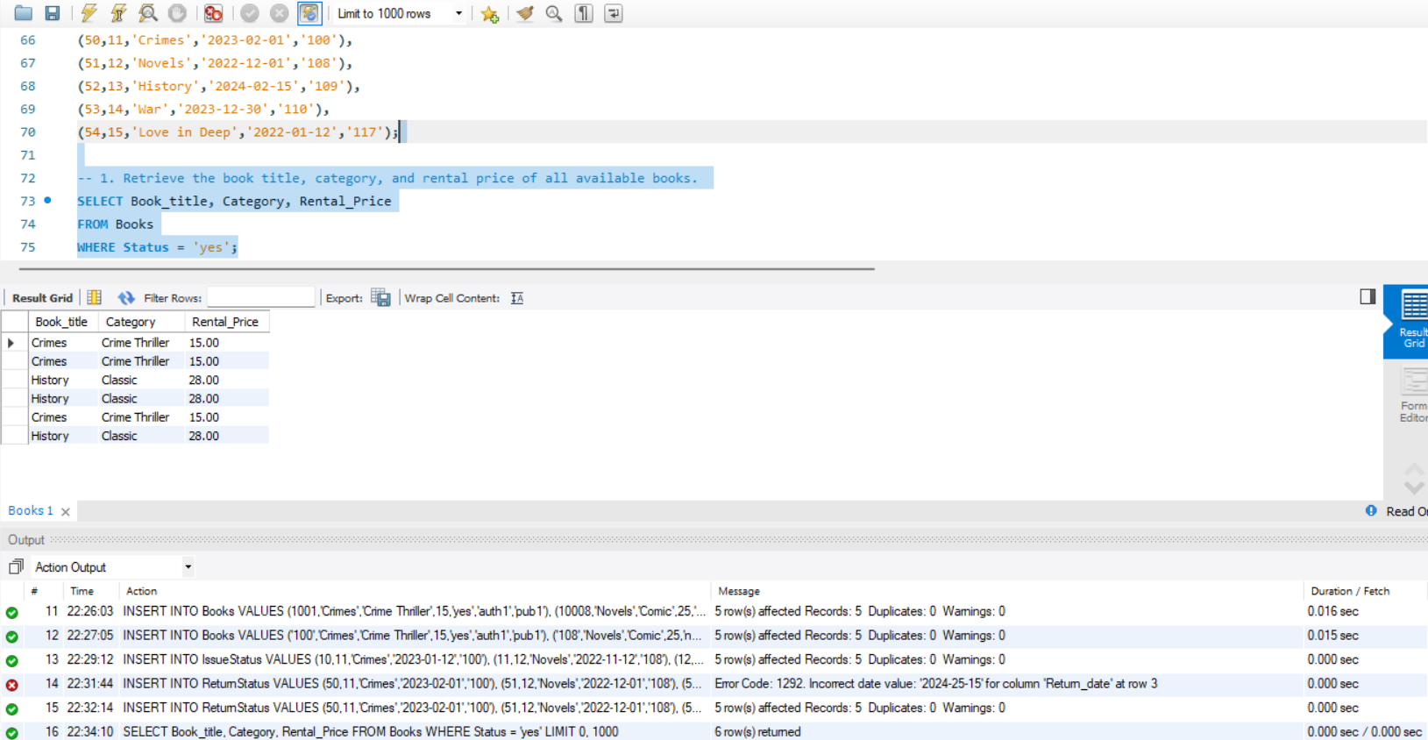

* List the employee names and their respective salaries in descending order of salary.

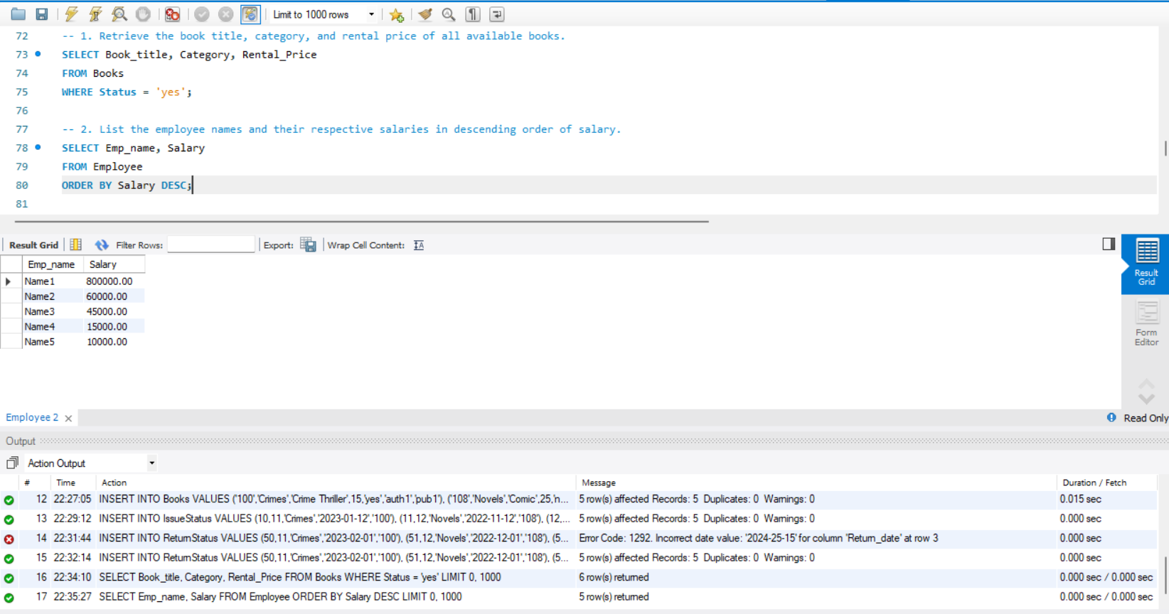

* Retrieve the book titles and the corresponding customers who have issued those books.

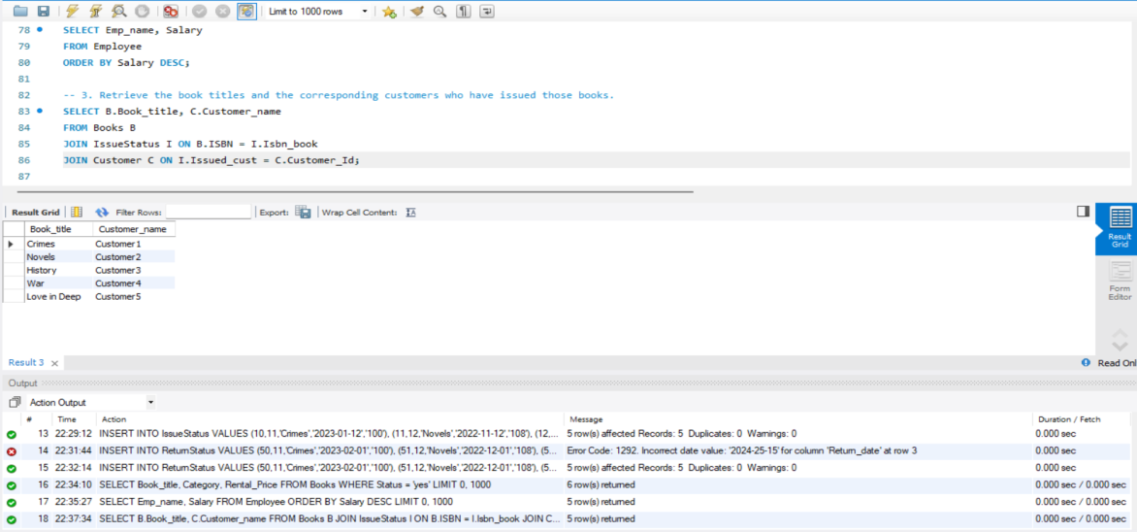

* Display the total count of books in each category.

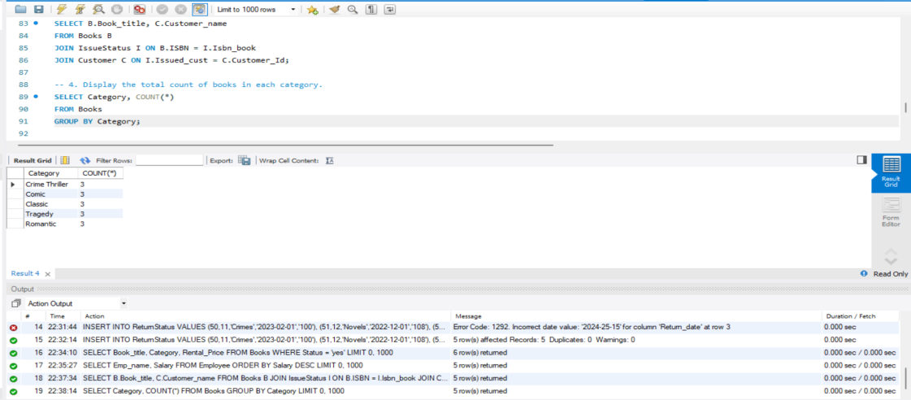

* Retrieve the employee names and their positions for the employees whose salaries are above Rs.50,000.

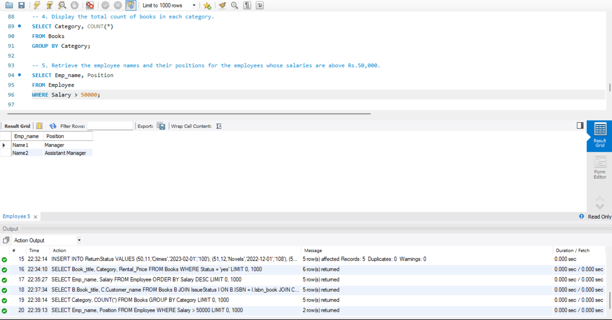

* List the customer names who registered before 2022-01-01 and have not issued any books yet.

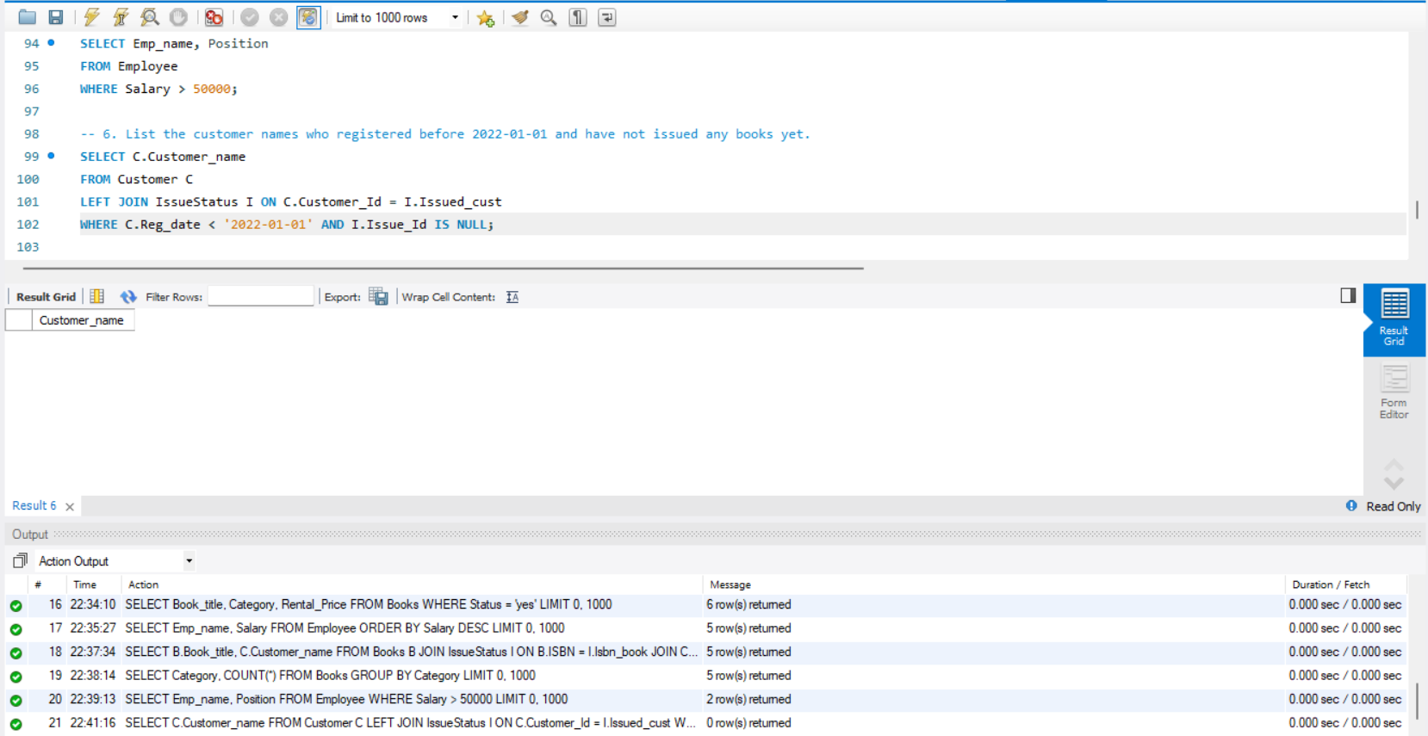

* Display the branch numbers and the total count of employees in each branch.

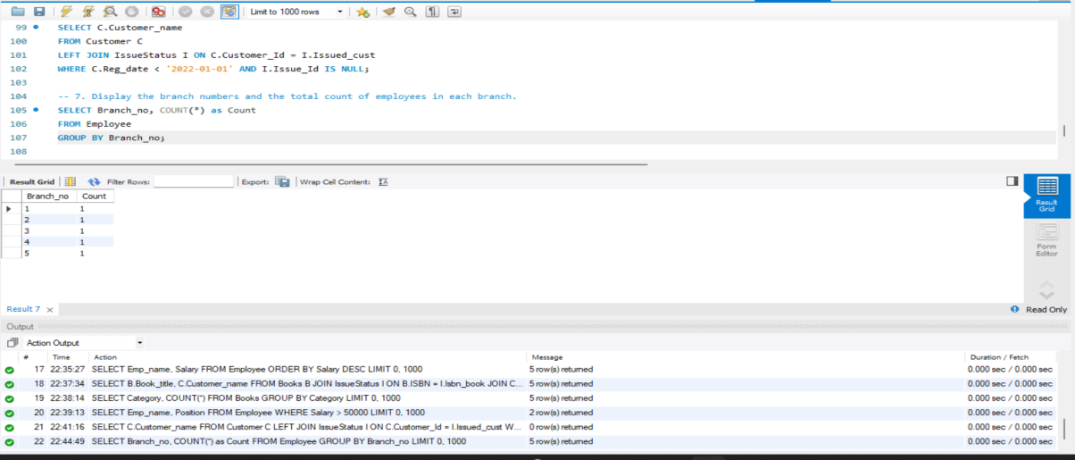

* Display the names of customers who have issued books in the month of June 2023.

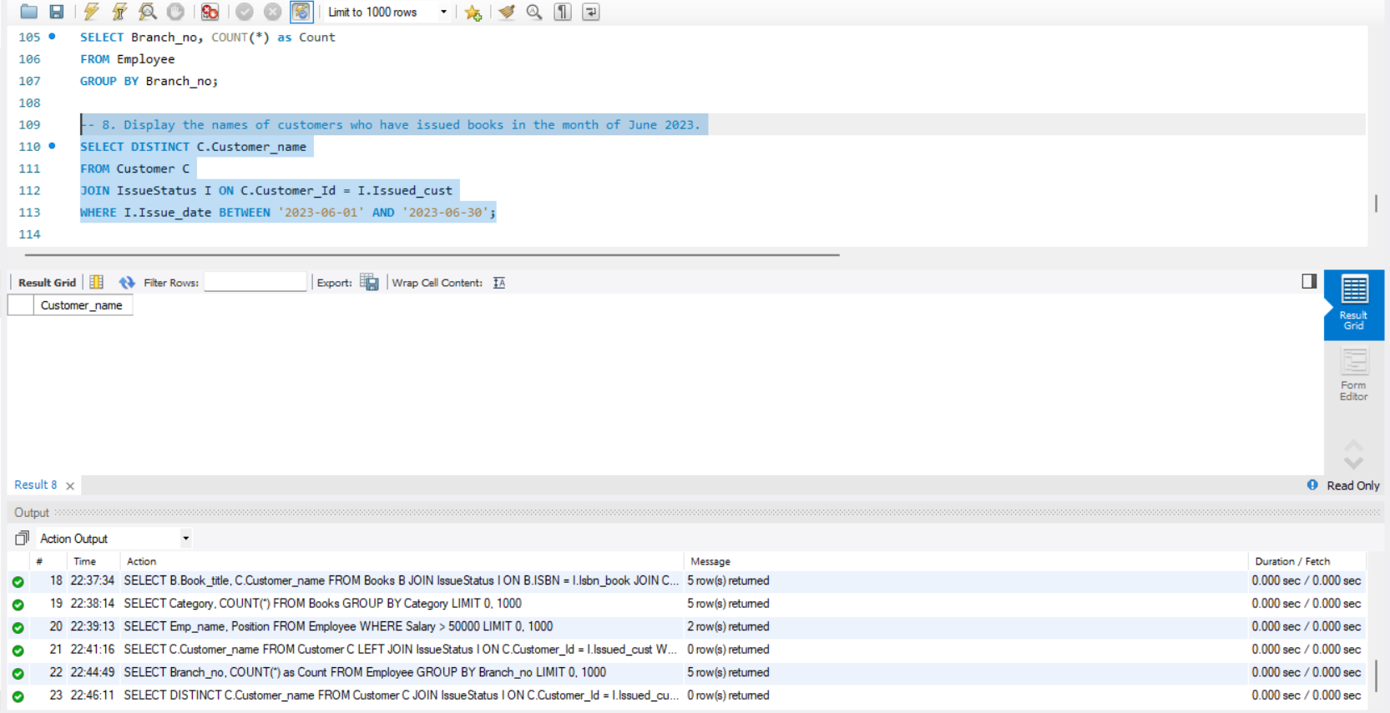

* Retrieve book_title from book table containing history.

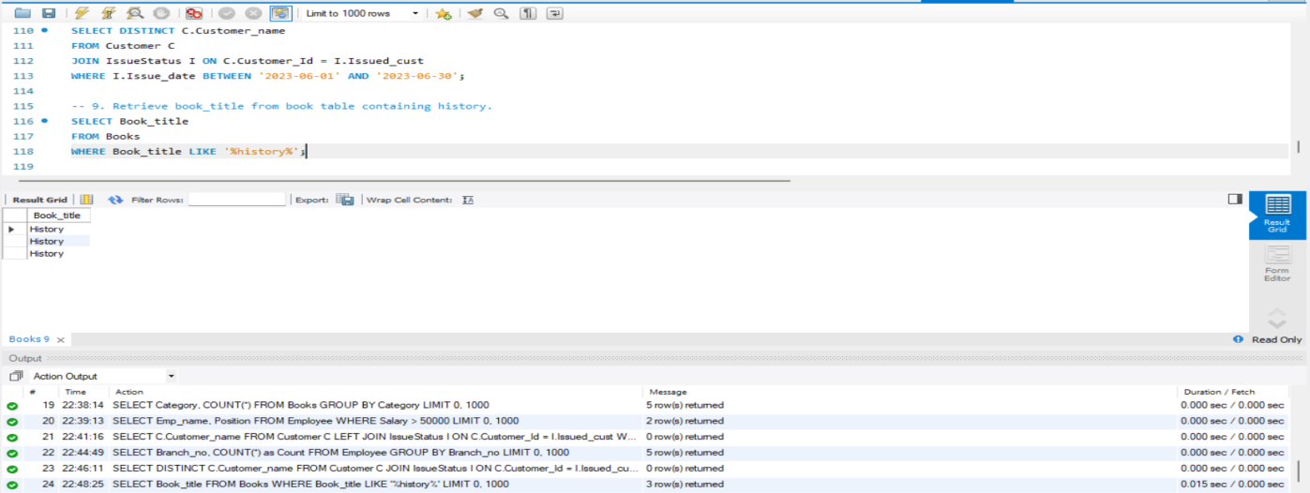

* Retrieve the branch numbers along with the count of employees for branches having more than 5 employees

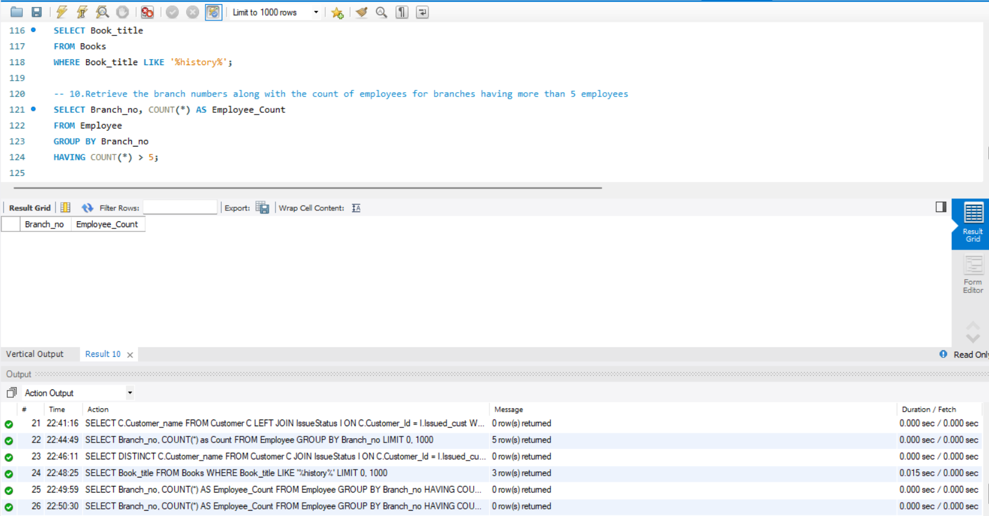

* Retrieve the names of employees who manage branches and their respective branch addresses.

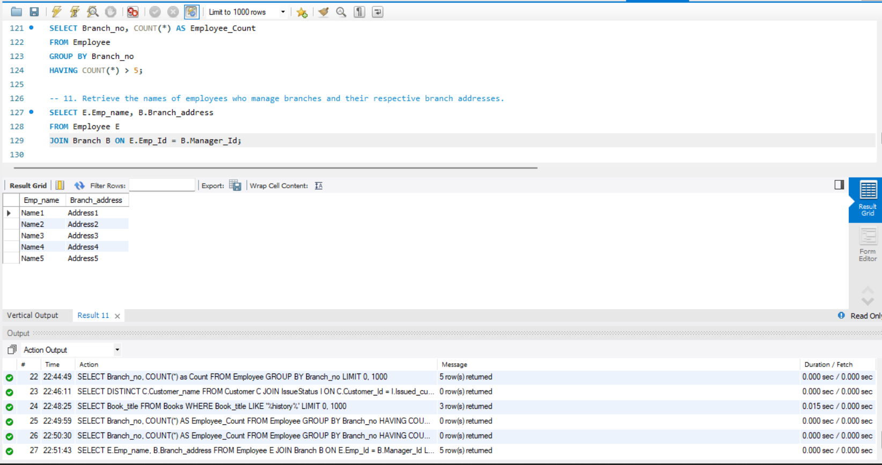

* Display the names of customers who have issued books with a rental price higher than Rs. 25.

